**1.ReactJS-HOL**

**Creation of React folder**

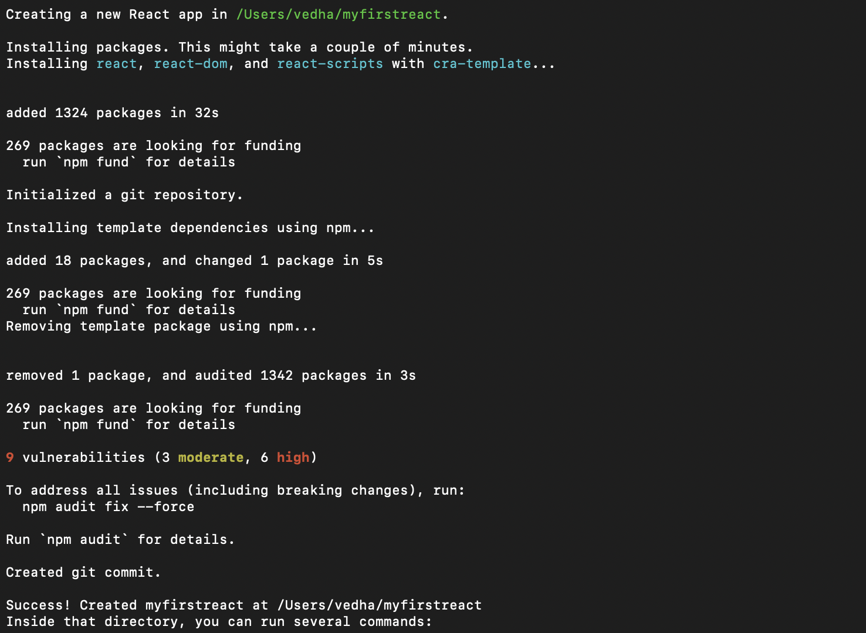

**App.js**

import logo from './logo.svg';

import './App.css';

function App() {

return (

<h1> Welcome the first session of React</h1>

);

}

export default App;

**Output:**

